Dear KATC Member,

**Personal Details -** Please note that the only personal details that we hold are what you have given us on the membership Application Form i.e., Name, Address, Telephone and Mobile numbers and email address (where applicable).

**Data usage -** Your personal details are not passed on to any third party without your consent. The membership database is only made available on a need to know basis i.e., Membership Secretary, Treasurer and Team Captains. We use your contact details to give notice of meetings, membership renewal and to keep you informed of news items e.g., Wimbledon Ticket Ballot, Social Events, Club Tournaments etc.

**Data Retention –** We keep your personal data for as long as necessary for each purpose we use it. For most membership data, this means we retain it for as long as you have a valid Kirkstall Abbey Tennis Club membership and for a period of six years after your last interaction with us.

**Access Rights –** You have a right to request copies of the data that we hold on you and we will provide this within one month of the request.

**Privacy Policy –** The full GDPR Privacy Policy will soon be accessible on the club website link – [**www.kirkstallabbeytennisclub.co.uk**](http://www.kirkstallabbeytennisclub.co.uk)*(control + click to follow link)*

Summer Coaching Available - Saturday Mornings

Starting May 2021 for 10 weeks (exact date tbc)

# **Free to Members**

## Juniors (up to 16 years old) 10.00am to 11.00am

## Adults (16+) 11.00am to 12.00pm

****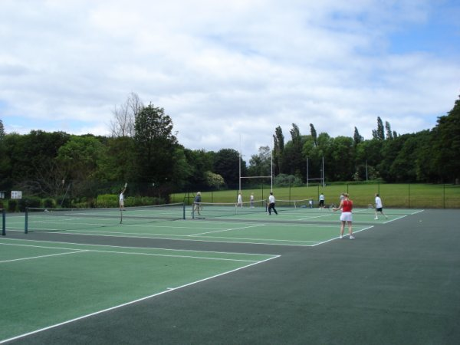

@katctennis



Kirkstall Abbey Tennis Club

To secure a place and assist with arrangements we are asking people to register their interest in attending the Saturday Coaching Sessions. If possible, please give your mobile number so we can text you if we have to cancel coaching at short notice due to adverse weather, or better still check us out on Facebook or Twitter and get more information about cancellations/disruptions or sharing lesson plans etc. Just Search/Find and like “Kirkstall Abbey Tennis Club” on Facebook or @katctennis on Twitter. **COVID-19 UPDATE: Details of any newly introduced booking system will be given as soon as it becomes available.**



**Please complete this section and return to Ronnie Ruelan (coach):**

E-mail: ronnieruelan@yahoo.co.uk **OR** Mob: Text your details to 07402-600699.

Name(s) ……………………………………………………………………………………………………...……………….

Address ……………………………………………………………………………………………………………..………..

………………………………………………………………………….. Mob. No.:…………………………………………

**Coaching Session (Please give numbers attending)**

Juniors (up to 16yrs) 10:00 – 11:00

Adults (16+) 11:00 – 12:00

**For further information or to enquire about individual coaching please contact our LTA Licensed Coach Ronnie Ruelan using the contact details above…**